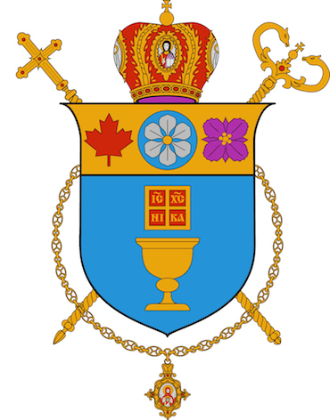

Chancery Office
Eparchy of New Westminster

12 March 2020
To the Clergy and the Faithful
of the Eparchy of New Westminster,

CIX!

Many of our parishioners are understandably concerned about the spread of the Coronavirus. We want to assure them of steps we are taking in our parishes to provide a sense of health and well-being so that their spiritual needs continue to be met, and that they may grow in their relationship with God, especially during Great Lent.

All liturgical services will continue to be celebrated publicly. However, we will follow closely the advice and directives from medical experts and government officials in Canada should they prescribe otherwise.

By way of responding to the Coronavirus Disease, the following liturgical norms can be helpful in protecting ourselves and family from COVID-19:

- Wash your hands often and well.
- Avoid touching your face, nose, or mouth with unwashed hands.
- Avoid close contact with people who are sick.
- Clean and disinfect surfaces that are frequently touched.
- Stay at home and away from others (particularly the elderly as they are most vulnerable) if you are feeling ill.
- When sick, cover your cough and sneezes with a sleeve or tissue and then wash your hands.
- Upon entering and exiting the Church, wash your hands with provided antibacterial hand sanitizers.
- Holy Water fonts (where they exist) at the entrance of the Church have been removed.
- Refrain from kissing icons and hand crosses.
- Offer the Kiss of Peace at the Divine Liturgy by simply bowing to each other.
- At this time, the Divine Eucharist will be distributed as usual. When you approach, open your mouth as wide as possible, and do not allow your lips or tongue to touch the spoon.

For up to date information on the Corona virus, visit reliable sources, for example, Ministry of Health – British Columbia and Public Health Agency of Canada.

Let us do what we do best as the people of God, let us pray:

Prayer During the Coronavirus Outbreak

Lord, Our God,
We thank you for the life that is your gift,
For the providence that sustains us,
And for your wisdom that directs the course of our days.
The threat of an infection of coronavirus is upon us today.
This disease causes fear among us and has claimed lives.
We humbly beg you, loving Lord,
Dispel our fear and deliver us from this and other diseases.
Heal those who are afflicted and stop the spread of the virus.
Strengthen us in charity to care for one another.
For You are a God of mercy, kindness, and love, and we glorify You
Father, Son, and Holy Spirit, now and for ever and ever. Amen.

God bless!

Bishop David

